Cal Poly Pomona

CS470 Game Development

Spring Quarter

2017

*****************************************************************

Documentation type: Concept Document

Project: The Farting Panda

Team: BaDkINgZ

Members: Mahmudur Khan,

Nathaniel Krueper,

Benjamin Krueper,

Chu Yiu Cheung,

Ian Stodart

Professor: Tony Diaz

*****************************************************************

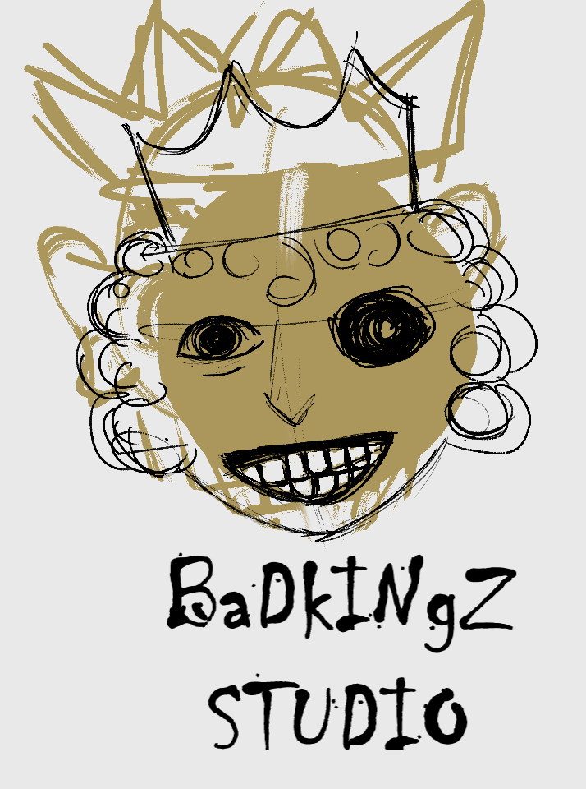

**High Concept**:

The Farting Panda is a 2D platformer game where the main character, the farting panda, searches for his one true love while the panda hunters move in for his valuable fur.

**Game Story:**

Mating season in Bambooland has just begun, a farting panda sets out to find his ultimate soulmate. Standing between them are treacherous natural terrains and the vicious panda hunters. Can the brave farting panda overcome the adversaries and answer his true love’s mating call before the mating season ends?

**Features:**

Throughout the game, we will implement challenging jumping puzzles, smart enemy AIs, and quirky sound effects to make the game fun to play.

**Play and Look:**

The player will play as the farting panda as he wanders through Bambooland in search for his true love. The game mechanics will be similar to any other platformers of the 90s such as Contra, Mario, and Flappy Bird. The player will move to the right to progress, maneuver through obstacles, and avoid or kill panda hunters. There will be collectable items such as bamboos, which after consumption, allows the player to use fart attacks to kill the panda hunters. The final objective is to meet the female panda at the end. See concept drawings below.

**Technical Details:**

We will develop the game mainly on Unity 2D engine and model

the game world using Unity and/or Blender version 2.78. The game is intended for desktop computers, but future development on mobile platform is possible.

**Expected Audience**:

The Farting Panda is appropriate for everyone and aiming for the Everyone 10+ (ESRB) rating.

**Estimated cost:**

The Farting Panda will need 3-5 weeks development time with 5 developers paid $0/hour.

**Risk Analysis:**

There are two risk factors which might negatively affect production:

1. Game mechanics being too difficult to implement

2. Object models being too difficult to perfect

Possible solutions to the above risks:

1. Tune down the complexity of the game mechanics without

reducing the amount of features.

2. Start with simpler character/object designs.

**Concept Drawings:**

1. Gameplay concept

I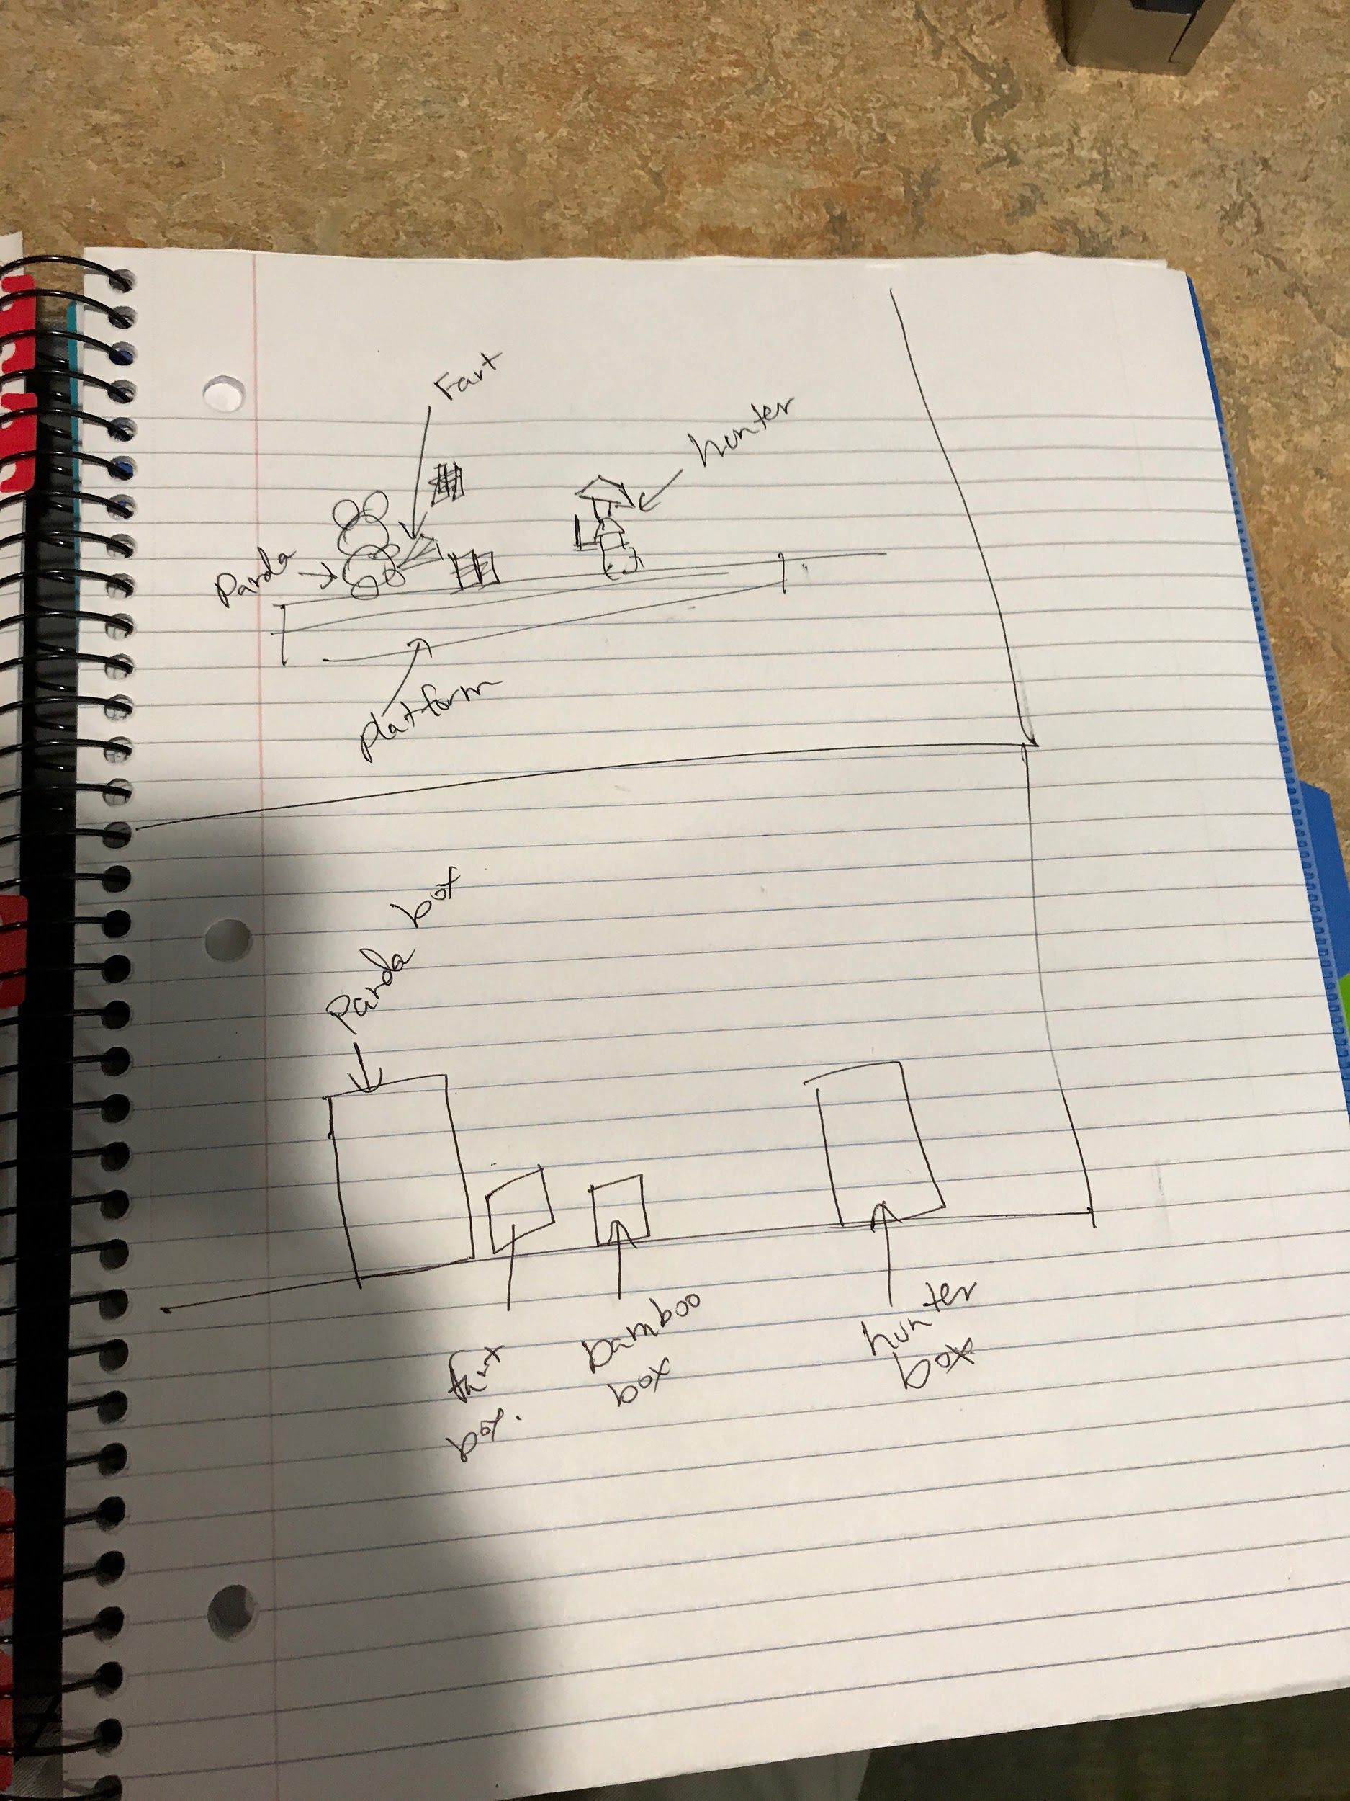

2. Example of an actual screen during gameplay

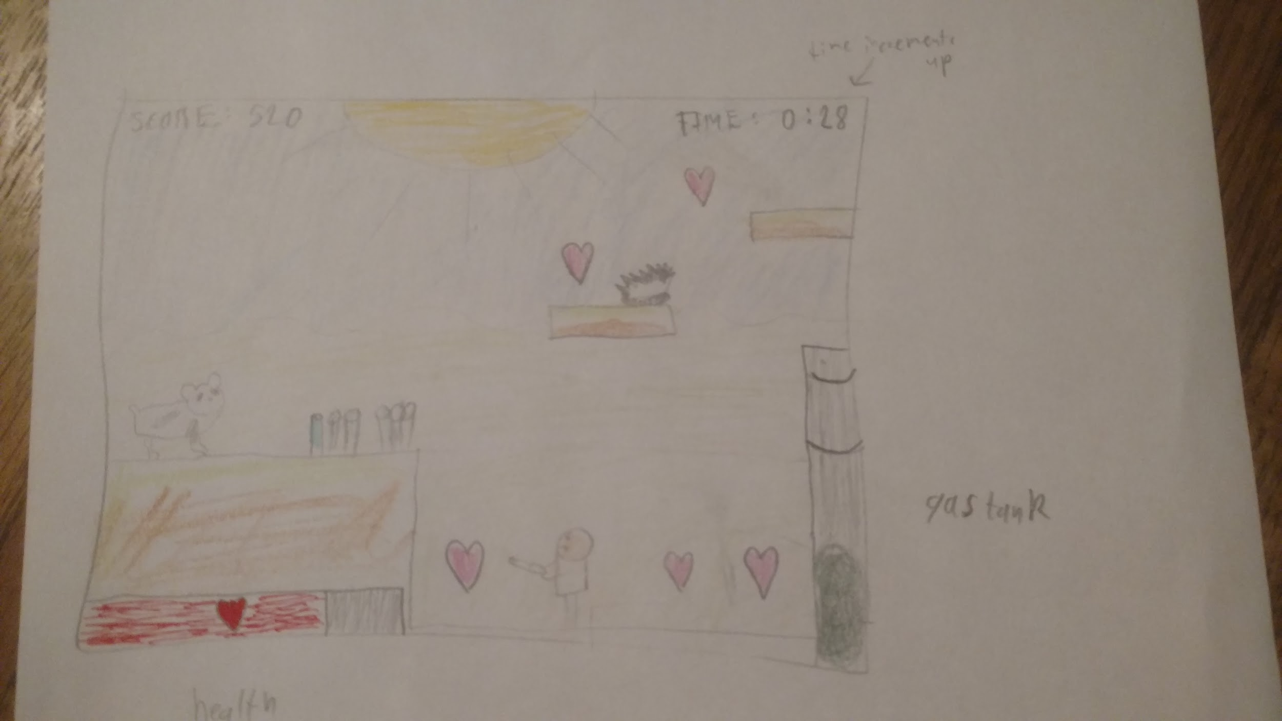

**Gameplay**:Action

**Style**:Action Platformer

**Purpose**:Entertainment

**Target Audience**:E 10+ (for some crude humor)

**Presentation**:2D side scrolling

**Artistic Style**:Cartoon

**Temporal Aspect**:Real-time

**Theme**:Nature

**Setting**: Jungle

**Mood/Affect**: Cute, light-hearted

**Type of ending**: Finite